The Centrosomal Ledger
A Unified Model of Structural Memory in Cellular Aging and Fate Determination
Jaba Tkemaladze ^ ¹
Affiliation: ¹ Kutaisi International University, Georgia
E-Mail: djabbat@gmail.com

Abstract
This article is a Perspective presenting a unifying conceptual framework that integrates existing experimental observations into a testable model of centrosome-based structural memory. While it does not report new experimental data, it aims to stimulate hypothesis-driven research and translational exploration in aging, cancer, and regenerative medicine. The centrosome, traditionally regarded as the primary microtubule-organizing center of animal cells, is here reconsidered from a translational and systems-level perspective. This Perspective advances a unifying hypothesis—the Centrosomal Ledger Model—proposing that the mother centriole functions as a non-genetic, structurally encoded repository of cellular history. Through the cumulative accumulation of post-translational modifications, retained regulatory proteins, and stress-associated molecular marks, the centrosome integrates replicative age, metabolic state, and environmental exposures. Importantly, this model provides a mechanistic bridge between structural cell biology, disease-associated omics signatures, and fate decisions relevant to aging, cancer, and regenerative decline. Discuss how centrosomal states may be reflected in proteomic, epigenomic, and metabolomic readouts, and how their misinterpretation or corruption contributes to pathological outcomes such as stem cell exhaustion, tumorigenesis, and impaired tissue regeneration. By framing the centrosome as an information-processing hub rather than a passive scaffold, this Perspective highlights novel, testable intervention points for translational research aimed at modulating cellular aging and restoring regenerative competence.
Keywords: Centrosome; Centriole; Cellular Memory; Structural Inheritance; Aging; Cancer; Regenerative Medicine; Omics; Translational Medicine; Stem Cell Fate.

1. Introduction: Beyond the Microtubule Organizer
The canonical view of the centrosome frames it as an orchestrator of spatial order: it nucleates and anchors microtubules, establishes cell polarity, and forms the poles of the mitotic spindle (Bornens, 2012). However, several persistent observations defy a purely structural explanation. The mother centriole's remarkable longevity, its asymmetric inheritance during stem cell divisions, and its role as a platform for signaling complexes suggest a deeper, information-centric function (Venkei & Yamashita, 2018). I hypothesize (Tkemaladze, 2023) that the mother centriole has evolved to function as a cellular ledger—a durable, non-genetic data storage device that logs biographical data and computes cellular fate.
This article integrates disparate lines of evidence into a coherent model. We first define the molecular language of the ledger (Section 2), then describe the cellular machinery for reading it (Section 3). We place this mechanism within the hierarchy of biological timing systems (Section 4), examine its variation across cell types (Section 5), and trace its evolutionary origins (Section 6). We propose critical experimental tests (Section 7), explore broader implications (Section 8), and present a formal integrative model (Section 9).

2. The Molecular Syntax of the Ledger: Encoding Time and Experience
The centriole's cylindrical, nine-fold symmetric structure of stable microtubule triplets provides an ideal, low-turnover substrate for information encoding. Data is written via two primary classes of molecular notations.

2.1. Post-Translational Modifications as Chronological and Damage Marks
The tubulin backbone undergoes progressive PTMs that serve distinct purposes.
- Neutral PTMs (Replicative Tally): Enzymatic modifications like polyglutamylation accumulate predictably with each cell cycle on the mother centriole. They act as a maturity index, marking functional readiness for roles like basal body formation (Bré et al., 2021). The level of polyglutamylation (PolyG) can be conceptualized as a function of division number (n):
PolyG(n) ≈ PolyG(n-1) + ΔG
where ΔG represents the addition per cycle.
- Pathological PTMs (Stress Log): Stochastic, damage-associated modifications create a damage index. This includes oxidation of scaffold proteins (e.g., SAS-6), glycation of long-lived proteins (e.g., CEP135), and ubiquitination marking misfolded clients (Wang et al., 2021). These correlate with functional decline.

Table 1: Molecular "Writes" to the Centrosomal Ledger
Modification Type | Example | Proposed Information Encoded | Functional Consequence
Neutral PTM | Polyglutamylation | Number of successful divisions (Maturity) | Stabilization; recruitment of specific effectors (e.g., ciliary assembly proteins)
Neutral PTM | Acetylation (K40) | Age of microtubule structure | Reduced dynamics, increased mechanical resistance
Pathological PTM | Cysteine Oxidation | History of oxidative stress | Weakened structural integrity, errors in duplication
Pathological PTM | Advanced Glycation End-products (AGEs) | Cumulative metabolic stress | Loss of protein function, aggregation propensity
Protein Retention | CAFDs (e.g., YAP/TAZ) | Past signaling context (e.g., Hippo pathway activity) | Altered transcriptional preparedness upon release

2.2. Proteomic Composition as a Snapshot of State
Beyond PTMs, the ledger's proteome is dynamic. The mother centriole selectively retains Centriole-Associated Fate Determinants (CAFDs)—proteins like transcription regulators and kinases—whose presence reflects the cell's recent signaling history (Jakobsen et al., 2011). The composition of distal appendage proteins and recruited chaperones (e.g., HSP90) further provides a real-time snapshot of centriolar age and stress.

3. Decoding the Ledger: Cellular Read-Out Mechanisms
The stored information is biologically inert until interpreted. Cells employ parallel pathways to read the ledger's state.
Mechanical Read-Out. The centrosome's core output is microtubule nucleation. A ledger with high damage/maturity indices nucleates a less dynamic, more rigid microtubule array. This altered mechanical output is sensed by +TIP proteins (e.g., EB1) and transmitted via the LINC complex to the nucleus, influencing chromatin organization and gene expression (Lomakin et al., 2015).
Signaling Read-Out. As the basal body, the mother centriole dictates primary cilium integrity. A damaged ledger leads to a defective cilium, misinterpreting morphogen signals like Sonic Hedgehog (Shh), thereby altering transcriptional programs for fate and proliferation (Breslow & Holland, 2019).
Proteostatic Read-Out. Accumulated pathological PTMs chronically recruit protein quality control systems (chaperones, ubiquitin ligases). Sustained engagement can spill over to activate global stress responses like the Unfolded Protein Response (UPR), a known driver of senescence (Conroy et al., 2022).

Figure 1: The Information Cycle of the Centrosomal Ledger. (A schematic showing: 1. Inputs of Replication & Stress, 2. Molecular Writing (PTMs, CAFDs), 3. The Stable Ledger (Mother Centriole), 4. Parallel Read-Out Pathways (Mechanical, Signaling, Proteostatic), 5. Fate Decisions (Renewal vs. Aging Programs)).
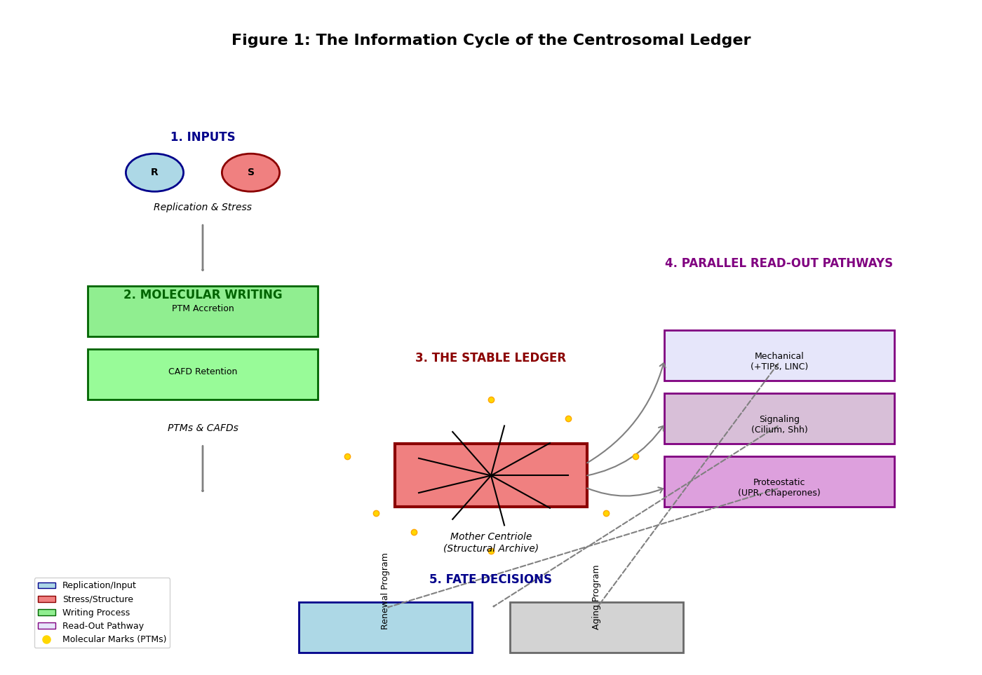

4. The Ledger in the Hierarchy of Biological Clocks
The centrosomal ledger is not an isolated timer but a key node in a network.
- Level 1: Fast Oscillators. Circadian clock proteins (e.g., PER2) localize to centrosomes, suggesting the ledger integrates daily metabolic rhythms with long-term age data (Wils et al., 2021).
- Level 2: Replicative Clocks. The ledger interacts with telomeric and epigenetic clocks. Centriole dysfunction induces genomic instability, accelerating telomere attrition. Conversely, epigenetic changes may lock in a "senescent" interpretation of ledger data.
- Level 3: Systemic Aging. In stem cells, asymmetric inheritance of a "young" vs. "old" ledger determines self-renewal vs. differentiation balance. Age-related decline in this process depletes regenerative niches, driving tissue aging (Geiger et al., 2013).

5. Comparative Cell Biology: Ledger Adaptations
The ledger's function is tailored to cellular destiny.
- Germline: Employs strict asymmetric inheritance and stringent quality control to reset the ledger, minimizing intergenerational damage transfer (Fishman et al., 2018).
- Somatic Stem Cells: Exhibits "leaky" asymmetry, where imperfect segregation gradually increases damage load in the stem pool, contributing to niche aging.
- Differentiated Cells: The ledger is "paused"; the centriole becomes a static basal body, with age-related damage manifesting as ciliopathies.
- Cancer Cells: The ledger is "hijacked"—amplification and structural distortion disrupt normal timekeeping, enabling unchecked proliferation at the cost of genomic instability (Marteil et al., 2018).

Table 2: The Centrosomal Ledger Across Cell Types
Cell Type | Ledger State | Inheritance Mode | Primary Time-Related Output
Germ Cell | Reset, Immortal | Strictly Asymmetric | Fertility, generational continuity
Somatic Stem Cell | Aging, Leaky | Asymmetric (with error) | Tissue homeostasis, niche depletion
Differentiated Cell | Paused, Static | Symmetric / Non-dividing | Sensory function, age-related ciliopathies
Cancer Cell | Corrupted, Amplified | Aberrant, Symmetric | Uncontrolled proliferation, genomic instability

6. Evolutionary Origins: Why the Centriole?
The centriole was pre-adapted for this role. Its evolution from a motile basal body in unicellular organisms to a spindle organizer provided structural stability and obligatory inheritance. In metazoans, its inherent asymmetry was co-opted for asymmetric cell division. Finally, in long-lived animals, its durability made it ideal for recording time, transforming it from a structural organelle into an informational ledger (Carvalho-Santos et al., 2011). Plants, lacking centrioles, must utilize alternative systems (e.g., nuclear envelope microtubule nucleation), highlighting the ledger as an animal-specific solution to managing cellular time in complex, motile organisms.

7. Experimental Framework and Falsifiability
The model generates testable predictions:
- Prediction: Targeted reversal of centriolar PTMs (e.g., deacetylation, redox repair) in aged stem cells will rejuvenate function.
- Prediction: Microinjection of in vitro "aged" (glycated/oxidized) centrioles into young cells will induce senescence markers.
- Prediction: Comparative biology will show that centriole-less organisms (plants) rely on fundamentally different primary drivers for stem cell aging.
A critical falsification would be if interventions that successfully reset other aging clocks (telomeres, epigenetics) fully rejuvenate cell function independent of the centriolar state.

8. Philosophical and Practical Implications
This model challenges genetic reductionism, arguing for structural inheritance as a crucial layer of biological information. It materializes time, defining cellular age as the physical state of the ledger. Practically, it identifies the centrosome as a novel therapeutic target. Strategies could include: 1) Ledger "Cleansing" (enzymatic repair of PTMs), 2) Ledger "Stabilization" (chaperone enhancement), and 3) Ledger "Reset" (promoting asymmetric inheritance of young templates in stem cells).

Application Prospects in Aging, Cancer, and Regenerative Medicine
The Centrosomal Ledger Model has direct implications for disease biology and translational intervention, particularly in contexts where cellular timekeeping and fate regulation fail.

Aging and Degenerative Decline
In aging tissues, progressive distortion of the centrosomal ledger may contribute to stem cell attrition and loss of regenerative capacity. Age-associated proteomic and PTM-based omics signatures observed in stem cell compartments may partially originate from altered centrosomal states. Therapeutic strategies aimed at restoring centrosomal proteostasis or selectively resetting ledger-associated marks could synergize with existing epigenetic and metabolic rejuvenation approaches.

Cancer
Cancer cells exhibit profound centrosomal abnormalities, including amplification, structural elongation, and aberrant inheritance. Within the ledger framework, these changes represent corruption of structural memory, allowing cells to bypass normal temporal constraints on proliferation. Centrosome-focused omics profiling may therefore offer a complementary diagnostic dimension, while selective disruption of cancer-specific ledger states could expose vulnerabilities not addressed by genome-centric therapies.

Regenerative and Translational Medicine
From a translational perspective, the centrosomal ledger represents a candidate target for intervention in cell-based therapies. Quality control of centrosomal states in transplanted stem cells—potentially via proteomic or PTM-based biomarkers—may improve therapeutic durability and safety. Moreover, pharmacological modulation of centrosome-associated enzymes, chaperones, or signaling interfaces could enable partial functional rejuvenation without genetic reprogramming.
Together, these applications position the centrosome as a previously underappreciated but actionable node linking omics, disease mechanisms, and regenerative intervention.

9. The Integrative Centrosomal Ledger Model: A Formal Summary
We propose the cell's fate (F) is a function of the state (S) of its centrosomal ledger, integrated with other systems (genomic G, epigenetic E, metabolic M).
F(t) = Φ( S(L_m, L_d), G, E, M )
Where:
- L_m = Maturity Level (from neutral PTMs)
- L_d = Damage Level (from pathological PTMs)
The ledger state S transitions between zones that promote Renewal (R) or Aging (A) based on threshold crossings:
If L_d > Θ_d or L_m < Θ_m --> S = A (Engage Senescence/Apoptosis)
Else --> S = R (Promote Proliferation/Differentiation)

Figure 2: The Centrosomal Ledger State-Space Model. (A graph with Maturity (L_m) on the X-axis and Damage (L_d) on the Y-axis. A diagonal threshold line separates the "Renewal Zone" (low damage, high maturity) from the "Aging Zone" (high damage and/or low maturity). Arrows show trajectories for normal aging, cancer (high damage, reset maturity), and hypothesized rejuvenation.)
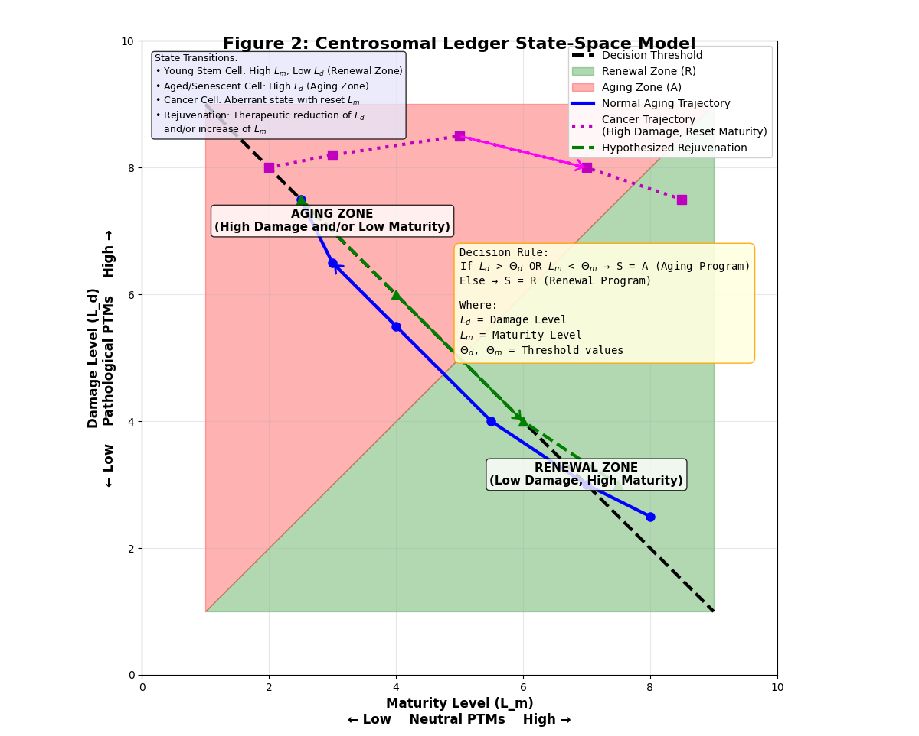

Conclusion
As a Perspective, the Centrosomal Ledger Model reframes the centrosome as a central integrator of structural memory, cellular time, and fate determination. By complementing genetic and epigenetic paradigms with a physically embodied record of cellular history, this framework offers new interpretative power for aging- and disease-associated omics data. Crucially, it opens a translational avenue in which centrosomal states themselves become targets for diagnosis, stratification, and intervention. Recognizing and modulating this structural layer of cellular information may prove essential for advancing therapies in aging, cancer, and regenerative medicine.

References
Bornens, M. (2012). The centrosome in cells and organisms. Science, 335(6067), 422–426. https://doi.org/10.1126/science.1209037
Bré, M. H., Redeker, V., & Levilliers, N. (2021). Post-translational modifications of tubulin and microtubule stability in cilia and flagella. In The Cytoskeleton: Diverse Roles in Structure and Mechanism (pp. 47-70). Springer, Cham. https://doi.org/10.1007/978-3-030-75867-7_3
Breslow, D. K., & Holland, A. J. (2019). Mechanism and regulation of centriole and cilium biogenesis. Annual Review of Biochemistry, 88, 691–724. https://doi.org/10.1146/annurev-biochem-013118-111153
Conroy, P. C., Saladino, C., Dantas, T. J., Lalor, P., Dockery, P., & Morrison, C. G. (2022). Centrosome adaptation to DNA damage by 53BP1 recruitment facilitates error-free mitosis. Nature Communications, 13(1), 620. https://doi.org/10.1038/s41467-022-28227-6
Carvalho-Santos, Z., Azimzadeh, J., Pereira-Leal, J. B., & Bettencourt-Dias, M. (2011). Evolution: Tracing the origins of centrioles, cilia, and flagella. The Journal of Cell Biology, 194(2), 165–175. https://doi.org/10.1083/jcb.201011152
Fishman, E. L., Jo, K., Nguyen, Q. P. H., Kong, D., Royfman, R., Cekic, A. R., ... & Avidor-Reiss, T. (2018). A novel atypical sperm centriole is functional during human fertilization. Nature Communications, 9(1), 2210. https://doi.org/10.1038/s41467-018-04678-8
Geiger, H., de Haan, G., & Florian, M. C. (2013). The ageing haematopoietic stem cell compartment. Nature Reviews Immunology, 13(5), 376–389. https://doi.org/10.1038/nri3433
Jaba, T. (2022). Dasatinib and quercetin: short-term simultaneous administration yields senolytic effect in humans. Issues and Developments in Medicine and Medical Research Vol. 2, 22-31.
Jakobsen, L., Vanselow, K., Skogs, M., Toyoda, Y., Lundberg, E., Poser, I., ... & Andersen, J. S. (2011). Novel asymmetrically localizing components of human centrosomes identified by complementary proteomics methods. The EMBO Journal, 30(8), 1520–1535. https://doi.org/10.1038/emboj.2011.63
Lomakin, A. J., Cattin, C. J., Cuvelier, D., Alraies, Z., Molina, M., Nader, G. P. F., ... & Piel, M. (2015). The nucleus acts as a ruler tailoring cell responses to spatial constraints. Science, 348(6232), 560–563. https://doi.org/10.1126/science.aaa2029
Marteil, G., Guerrero, A., Vieira, A. F., de Almeida, B. P., Machado, P., Mendonça, S., ... & Bettencourt-Dias, M. (2018). Over-elongation of centrioles in cancer promotes centriole amplification and mitotic defects. The EMBO Journal, 37(22), e100303. https://doi.org/10.15252/embj.2018100303
Tkemaladze, J. (2023). Reduction, proliferation, and differentiation defects of stem cells over time: a consequence of selective accumulation of old centrioles in the stem cells?. Molecular Biology Reports, 50(3), 2751-2761. DOI : https://pubmed.ncbi.nlm.nih.gov/36583780/
Venkei, Z. G., & Yamashita, Y. M. (2018). Emerging mechanisms of asymmetric stem cell division. The Journal of Cell Biology, 217(11), 3785–3795. https://doi.org/10.1083/jcb.201807037
Wang, W. J., Acehan, D., Kao, C. H., Jane, W. N., Uryu, K., & Tsou, M. F. B. (2021). The deubiquitinase USP33 regulates centrosome biogenesis via the SAS-6 protein. Journal of Cell Science, 134(2), jcs247155. https://doi.org/10.1242/jcs.247155
Wils, L., Rombauts, F., & van der Horst, G. T. J. (2021). The circadian clock and centrioles: Insights into the regulation of cell division. Seminars in Cell & Developmental Biology, 126, 78–84. https://doi.org/10.1016/j.semcdb.2021.04.023

